User Guide

# Objective

Manipulate your selected characters around the 10 by 10 map, utilizing their abilities and spells to eliminate your AI operated opposition.

Once all of the opposition have been removed from the map the player with the remaining characters wins.

# How to Play

1. Select your five characters and place them within the starting positions. (Characters can be of the same type, or varying)
2. Each character has strengths and weaknesses, keep note of them.
3. Move each of your characters around the map and complete an action
4. Completing an action can consist of an Attack, Spell, Ability or Waiting.
5. For every action a target must be selected.
6. Most actions are offensive and will cause the targeted characters health points to deplete
7. When a characters health reaches zero, they are removed from the game.
8. Defensive spells can be used to aid allies (Restore health points)
9. Once all of your characters have completed their turn, the AI will begin to operate.
10. 3-9 will be repeated until a team has no more characters to control.
11. The game will end and the victor will arise.

**Selecting Characters**

1 - Strengths and weaknesses

2 - Character stats

3 – Menu  
Select character  
Additional information (Spells & Abilities)   
Play (When 5 characters have been selected)

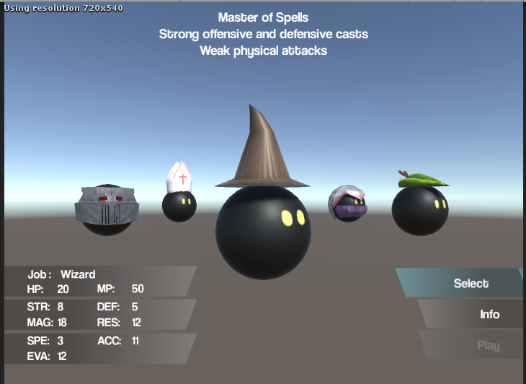

**Controls**

Left & Right arrows – Move carousel

A & D – Rotate character

Up & Down arrows – Move menu item

Enter – Select Menu item

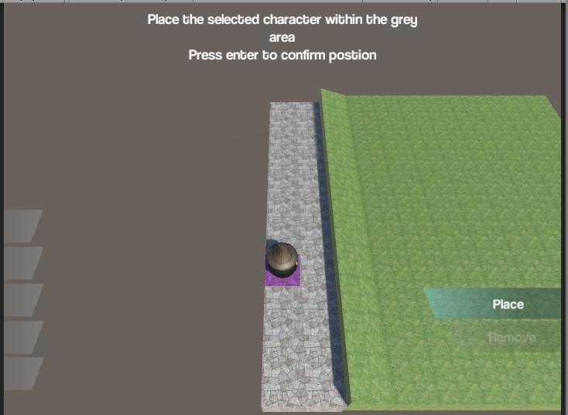

**Controls**

W, A, S, D – Move current position

Enter – Select Position or Remove

**Placing Characters**

1 - Available positions

2 - Current position

3 - Number of placed characters

4 – Menu  
Place Character  
Remove Character (When another character is in current position)

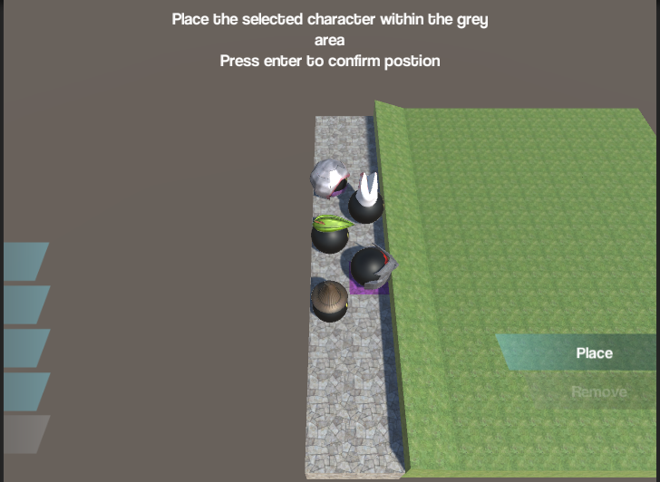

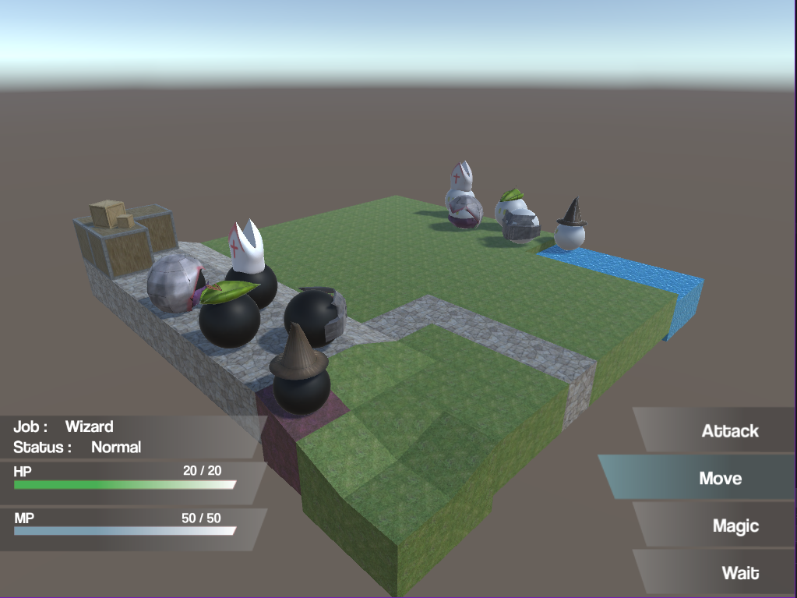

**Controls**

W, A, S, D – Move pointer

Up & Down arrows – Move menu item

Enter – Select menu item

**Map Layout**

1 - Player characters

2 - AI characters

3 - Pointer

4 - Selected character stats

5 - Menu

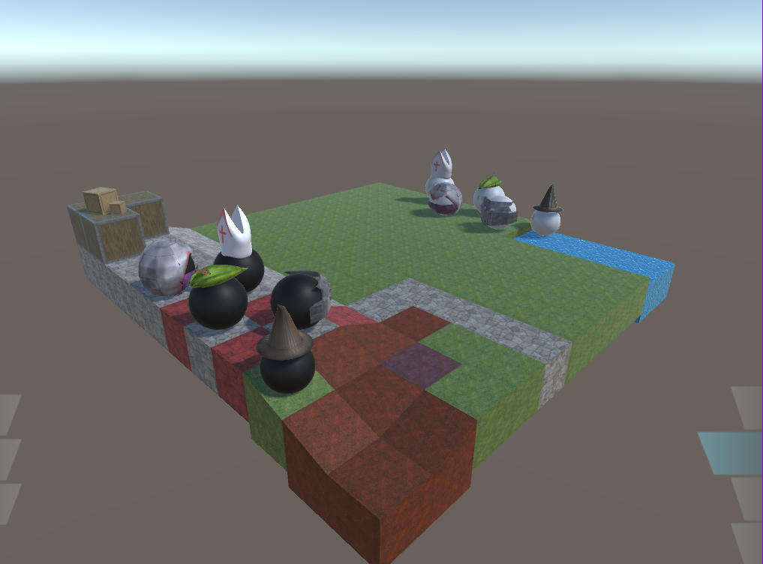

**Controls**

W, A, S, D – Move pointer

Enter – Select new position

**Move Action**

1 – Available spaces to move to

2 – Pointer

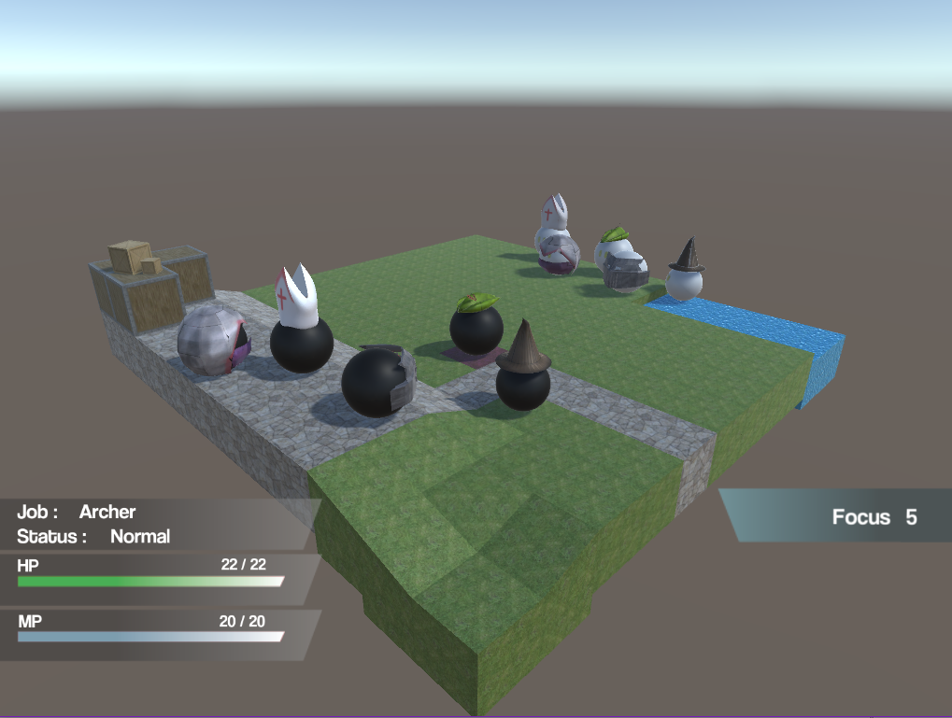

**Controls**

Enter – Select chosen ability

Right shift – Previous menu

**Ability Select**

1 – Ability name

2 – Ability Cost

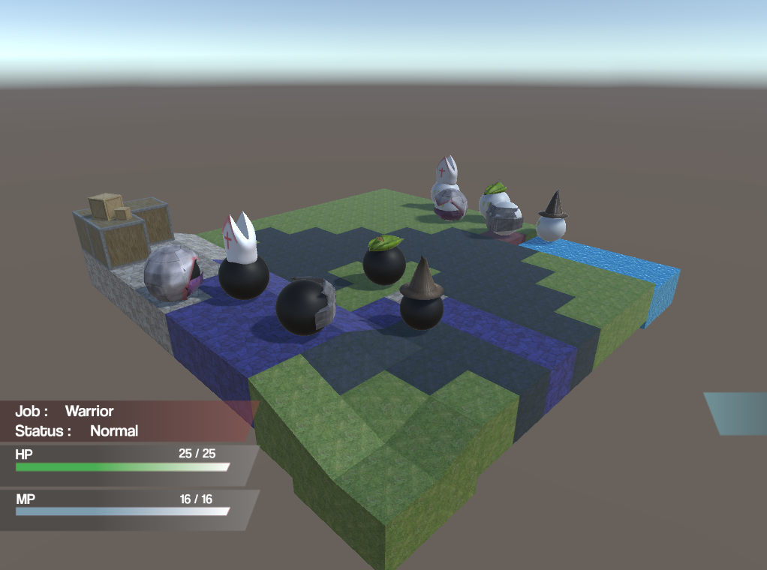

**Using an Ability**

1 – Ability cast range

2 – Target

3 – Target stats

**Controls**

Enter – Select target

W, A, S, D – Move pointer

Right shift – Cancel Action

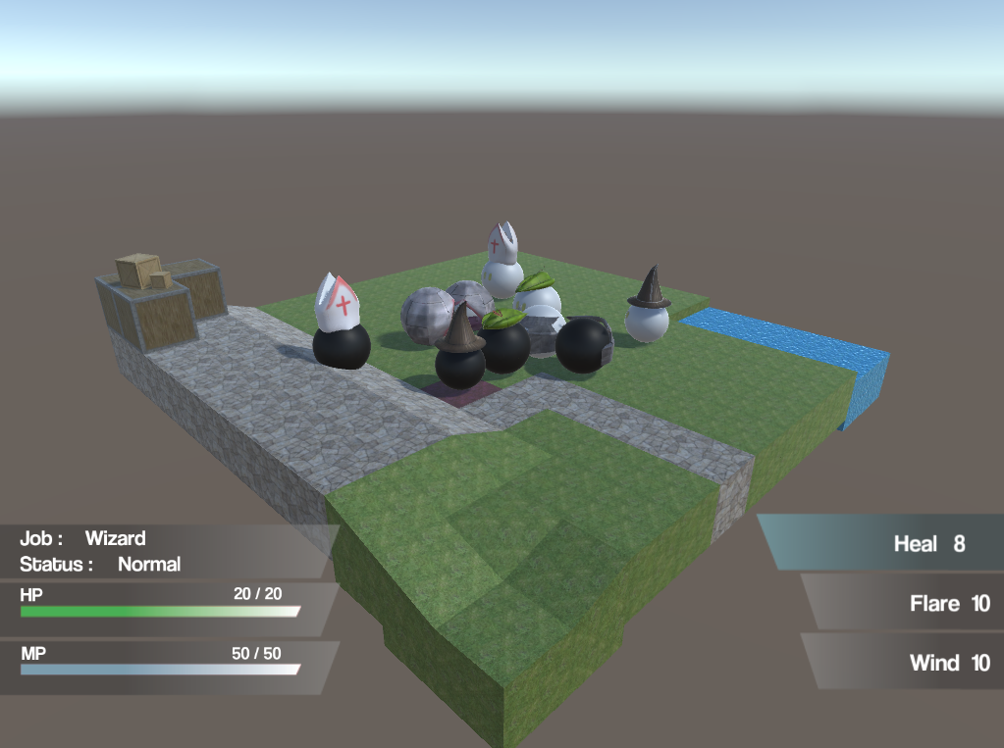

**Controls**

Enter – Select target

W, A, S, D – Move pointer

Right shift – Cancel Action

**Using a Spell**

1 – Spell cast range

2 – Target

3 – Target stats

**Controls**

Enter – Select chosen spell

Right shift – Previous menu

**Spell Select**

1 – Spell name

2 – Spell Cost

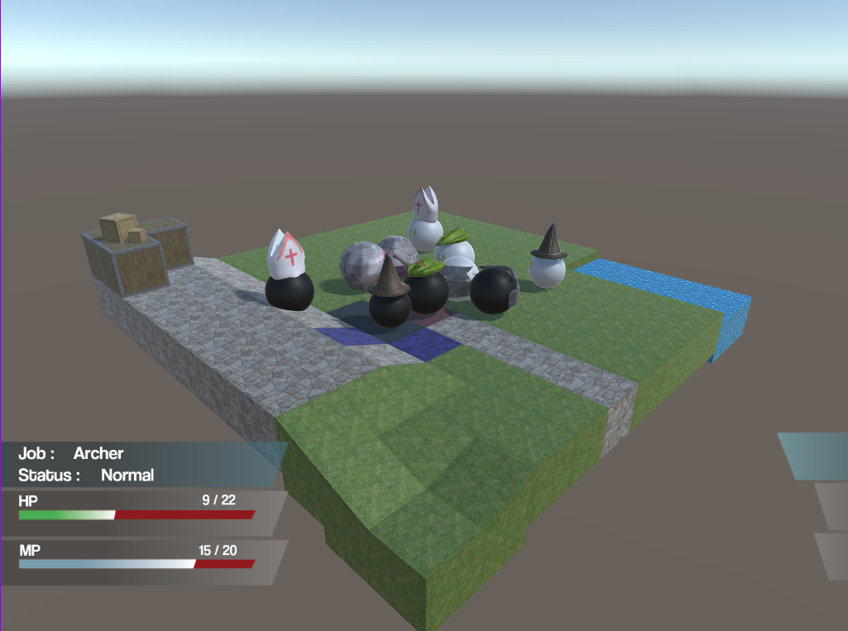

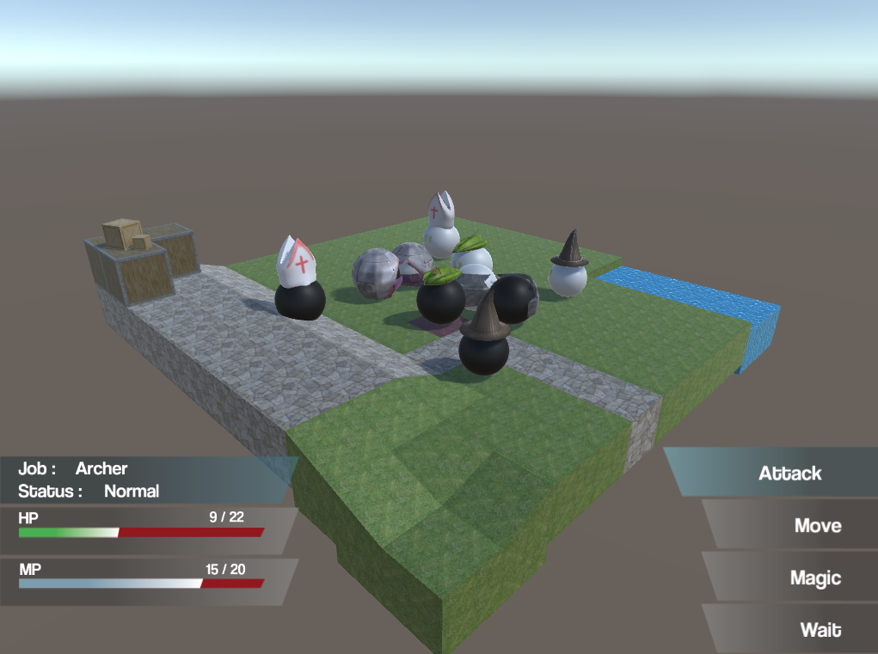

**Stats Bar**

1 – Pointer on ally

2 – Pointer on opposition

3 – Pointer on self

4 – Health points

5 – Mana points

